

SUBJECT | English Paper 1 |  | DATE | 13 July 2016
GRADE | 11 |  | MARKS | 90
EXAMINERS | Mrs Leeburn,  Mrs Nichas,  Mrs Oosthuysen  Mr De Reuck |  | MODERATORS | Mrs Nichas,  Mrs Leeburn,  Mrs Oosthuysen  Mr De Reuck
NAME |  |  | DURATION | 2 ½ Hours
CLASS
LOW ORDER | % | HIGH ORDER |  | %

INSTRUCTIONS
1. This question paper consists of x pages. Please check that your question paper is complete.
2. Utilise your reading time carefully.
3. Ensure that you number your questions as indicated on the question paper.
4. Begin each QUESTION on a new page. Do not copy down headings for your answers. Copy down only the question numbers, making sure they are accurate. You may answer the questions in whatever order you wish, but number your answers exactly as the questions are numbered.
5. Do not hesitate to give your own judgements. Attempt to create space in which your own voice is evident. The examiners will judge your answers on your understanding of, and insight into given texts, and will also assess the competence with which your answers are expressed.
6. Be guided by the number of marks allocated to each question. Aim at concise answers that give relevant information.
7. Answers must be written in the Answer Book supplied.
8. It is in your own interest to write legibly and to present your work neatly.

Question | 1 | 2 | 3 | 4 | Total | %
Possible Marks | 45 | 10 | 20 | 20 | 95
Marks Achieved

QUESTION 1 – comprehension, TEXTUAL EDITING 4 MARKS
Refer to TEXT 1 to answer the questions which follow:

  - Explain the impact of the emotive language in paragraphs 1 and 2 and evaluate how this aids the intention of the writer. (3)

1.2 1.2.1 What did the global comparison study reveal about the US and mass shootings? (2)
1.2.2 Why would there have been surprise about the results? (1)

1.3 What conclusions can be drawn by comparing the US incidents with those that happen world-wide? Refer closely to the passage to support your answer. (2)

1.4 To what extent do you believe mental illness to be a root cause of mass shootings in the US? Justify your answer. (3)

1.5 Explain the effectiveness of the metaphor used in paragraph 11 and how this informs the tone of this paragraph. (3)

1.6 Write a dictionary entry of copycat for its use related to mass shootings. (2)

1.7 Account for the copycat phenomenon being more prevalent in the US. (2)

1.8 Refer to the visual below and Extract 1. How would Bob Owens (Extract 1) use the visual to argue against the views of Jen Christensen, the writer of Text 1? (4)

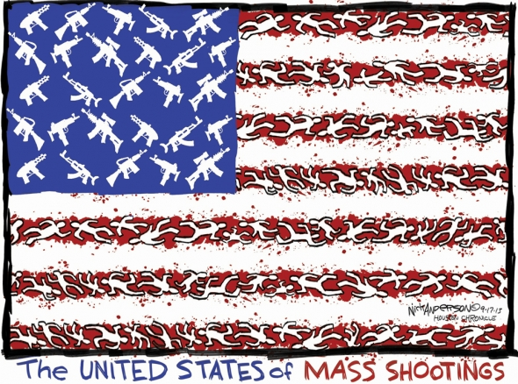

Extract 1
Bob Owens “How Many More Have To Die Before We Raise The Level Of Law Enforcement Training?”
I’ve been around firearms most of my life, and I’ve had no less than a half-dozen interactions with officers while armed with everything from a shotgun to handguns from my teens until now. In none of these instances have the officers cared that they saw a firearm in my possession (the shotgun I was carrying while hunting as officers combed the woods for a bank robber), or in the various times I’ve announced that I was carrying (as required by law in NC). In fact, they’ve never asked to see my permit after I told them I was a concealed carrier.
Is it because I’m a friendly-looking blond-headed white guy with laugh lines around my eyes? It is that I’m conscious of my demeanor, keep my hands in plain view, and move slowly?
Maybe it’s a combination of those things… and maybe it’s a law enforcement culture or even firearms training issue.
I’m not qualified to talk about department culture in any department, nor the individual officer’s biases, but I really would like to know what kind of firearms training he had, and how competent and confident he felt with his handgun. I ask because firearms training standards across this nation are very uneven in law enforcement, and less confident and competent officers are a very dangerous thing.
The simple fact of the matter is that if more people knew how little training officers were required to have with their deadliest tools, they’d be appalled.

1.9 Evaluate to what extent social media feeds the desire for fame? (3)

1.10 Do you believe that the Orlando shooting was “cause motivated”? Justify your answer. (3)
1.11 Identify and correct the spelling error in paragraph 3. (1)
1.12 Provide a reason why the word “fewer” in paragraph 9 is grammatically correct. (1)
1.13 “If this (Orlando) attack was motivated by radical Islamic fundamentalist ideology…”
1.13.1 Explain the effectiveness of the use of the passive form in the sentence above. (2)
1.13.1 Rewrite the sentence in the active voice and explain which sentence has the greater impact. (2)
1.14 “(Access to) firearms (is) a significant predictor of these incidents…”
14.1 Why has the writer included parenthesis in this sentence? (1)
14.1 Assess whether there is an error of concord in this sentence. Explain your answer. (2)
1.15 How does the writer’s use of pronouns and diction in the last paragraph position us to view the US? (3)

question 2 – summary 10 marks
Read TEXT 2 and answer the question below.
The College has decided to develop a conservation awareness campaign. Summarise TEXT 2 to be presented at a College Leaders’ Assembly to inform the boys of Trophy Hunting and to launch the awareness campaign.
Your summary should be no longer than 90 words in length. Please take note of the following rules for summary:
- Your response must be in the form of one coherent paragraph.
- You must use full sentences.
- Your language use must be accurate and in an appropriate register.
- Provide an appropriate title which is included in your word count.
- Provide an accurate word count at the end of the summary.
- Use your own words. 'Cutting and pasting' of information is not acceptable.

Question 3 – SEEN poetry 20 marks
Read the poem, Dulce et Decorum Est by Wilfred Owen and answer the following questions.

Dulce et Decorum Est - Wilfred Owen

Bent double, like old beggars under sacks, 1
Knock-kneed, coughing like hags, we cursed through sludge,
Till on the haunting flares we turned our backs,
And towards our distant rest began to trudge.
Men marched asleep. Many had lost their boots, 5
But limped on, blood-shod. All went lame; all blind;
Drunk with fatigue; deaf even to the hoots
Of gas-shells dropping softly behind.

Gas! GAS! Quick, boys!—An ecstasy of fumbling
Fitting the clumsy helmets just in time, 10
But someone still was yelling out and stumbling
And flound’ring like a man in fire or lime.—
Dim, through the misty panes and thick green light,
As under a green sea, I saw him drowning.

In all my dreams, before my helpless sight, 15
He plunges at me, guttering, choking, drowning.

If in some smothering dreams, you too could pace
Behind the wagon that we flung him in,
And watch the white eyes writhing in his face,
His hanging face, like a devil’s sick of sin; 20
If you could hear, at every jolt, the blood
Come gargling from the froth-corrupted lungs,
Obscene as cancer, bitter as the cud
Of vile, incurable sores on innocent tongues,—
My friend, you would not tell with such high zest 25
To children ardent for some desperate glory,
The old Lie: Dulce et decorum est
Pro patria mori.

3.1 Discuss how the diction used in stanza 1reflects the physical condition of the soldiers. 3

3.2 How does the use of punctuation in line 9 influence the pace of the poem? 2

3.3 Who is the speaker addressing in stanza 4? Why does he do this? 2

3.4 Which of the following two Propaganda Posters best characterise the speaker’s attitude towards war? Substantiate your answer with close reference to the poem and the posters. 4

POSTER A POSTER B
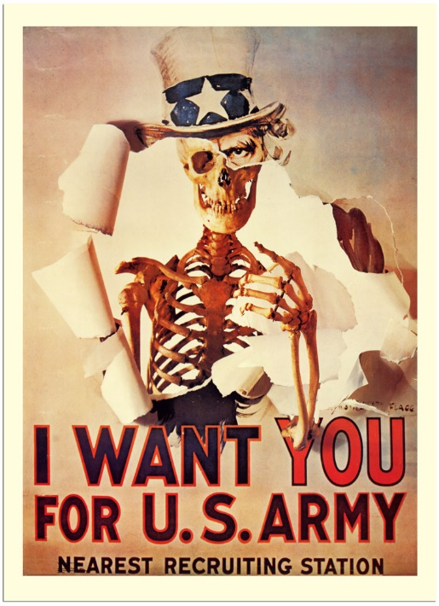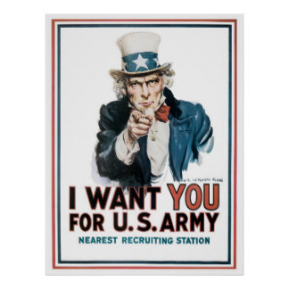

UNSEEN POETRY
Read the poem Who’s for the Game by Jessie Pope and answer the questions below.
Who's for the Game? – Jessie Pope
Who’s for the game, the biggest that’s played, 1
The red crashing game of a fight?
Who’ll grip and tackle the job unafraid?
And who thinks he’d rather sit tight?
Who’ll toe the line for the signal to ‘Go!’? 5
Who’ll give his country a hand?
Who wants a turn to himself in the show?
And who wants a seat in the stand?
Who knows it won’t be a picnic – not much-
Yet eagerly shoulders a gun? 10
Who would much rather come back with a crutch
Than lie low and be out of the fun?
Come along, lads –
But you’ll come on all right –
For there’s only one course to pursue, 15
Your country is up to her neck in a fight,
And she’s looking and calling for you.

3.5 What does the title Who’s for the Game? suggest about the speaker’s attitude towards war? 2

3.6 Explain the figurative meaning of the expression sit tight (line 4). 1

3.8 Suggest a reason why the use of personification in lines 16 – 17 is particularly
effective. 2
3.7 Identify two propaganda techniques used by the speaker and comment on the impact of each. 4

QUESTION 4 – VISUAL LITERACY 20 MARKS

The visuals below are concerned with the recent Tshwane riots and the SABC’s failure to broadcast them.
Study the visuals below and answer the questions that follow:
Visual 1
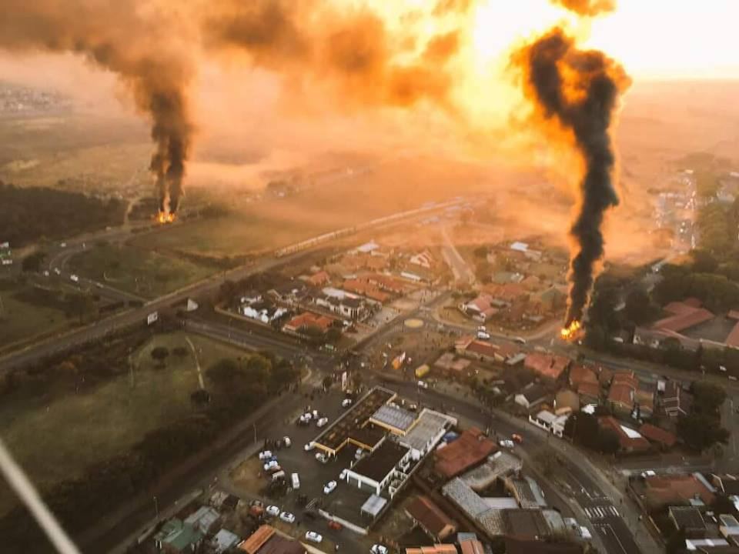

Visual 2
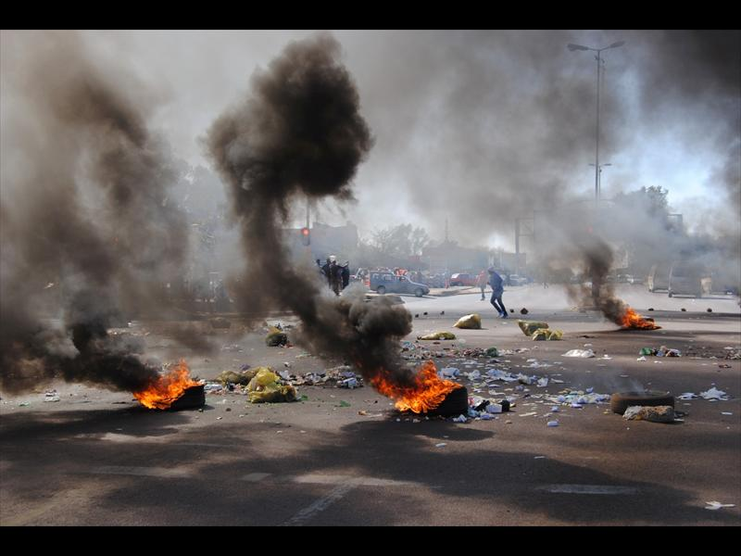

4.1 Compare and contrast visual 1 and visual 2. Which visual would you use as a front page photo to demonstrate the chaos of the Tshwane protests and why? 4

Visual 3
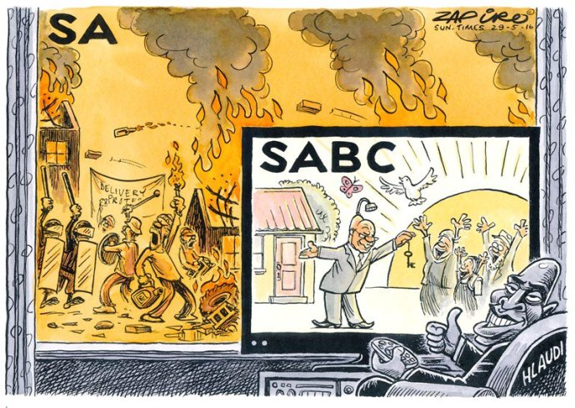
Hlaudi is the COO (Chief Operations Officer) of the SABC.

4.2 How does Zapiro portray the violence and chaos of the riots? 3
4.3 To what extent is Zapiro successful in illustrating censorship at the SABC? 3

4.4.1 What channel would Hlaudi be watching in this cartoon? 1

4.4.2 What is Zuma supposedly doing on the television in this cartoon? 1

4.4.3 Explain Zuma’s caricature portrayal in this cartoon. 2

4.4.4 How does Zapiro implicate Zuma in Hlaiudi’s decision not to broadcast the Tshwane riots?2

Visual 4
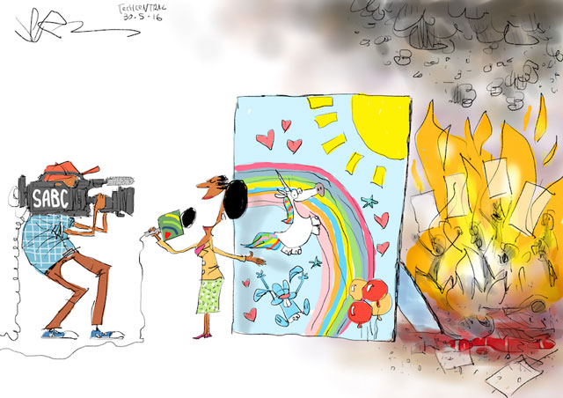
This is another cartoonist’s (Jerm) depiction of the SABC’s reporting of the Tshwane riots.

4.5 Which of the two cartoons (visuals 3 and 4) is more effective as a form of satire? Explain your answer. 4

TEXT 1

Why the U.S. has the most mass shootings Adapted from CNN, by Jen Christensen. Updated 1758 GMT (0158 HKT) June 12, 2016

1. When a gunman opened fire Sunday at a gay nightclub in Orlando, killing 50 people, the shooter joined a long line of attackers in the U.S. who have taken multiple lives in one incident.
2. When it comes to gun massacres, the United States is tragically exceptional: There are more public mass shootings in the United States than in any other country in the world, according to a study published recently.
3. Between 1966 and 2012, there were 90 mass shootings in the United States. Mass shootings are defined for the study as having four or more victims and don't include gang killings or slayings that involve the death of multiple family members. These shootings include the one in Orlando -- now the worst mass shooting in U.S. history -- and others in an Aurora, Colorado, movie theater and at Sandy Hook Elementary School in Newtown, Connecticut, both in 2012.
4. The 90 U.S. mass shootings are nearly a third of the 292 such attacks globally for that period. While the U.S. has 5% of the world's population, it had 31% of all public mass shootings.
5. "People have been a little surprised by these statistics," said Adam Lankford, professor of criminal justice at the University of Alabama, who did the analysis. It's the first research of its kind to do a global comparison.

How U.S. shootings are different
6. Lankford found a few common factors that set the U.S. incidents apart from the rest of the world's.
In the United States, people have a greater chance of dying in mass shootings if they're at work or at school. Overseas, these incidents typically happen near military installations.
7. In more than half the American cases, the shooter had more than one firearm. In global incidents, the shooter typically had only one gun.
8. And in the United States, there are 6.87 victims on average per incident. In the other 171 countries Lankford studied, the average was 8.8 victims per incident. Lankford said he thinks there are fewer people killed in these mass shootings in the United States because American police routinely train on how to deal with this kind of incident, even though it happens rarely compared with other kinds of crime.

The copycat phenomenon
9. What's behind all these mass slayings in the United States?
10. Many of the shooters in the United States were mentally ill, according to the data. But other studies have shown that the estimated number of cases of mental illness hasn't gone up significantly while the number of mass shootings in the U.S. has skyrocketed.
11. Some researchers believe these mass killings can be contagious: One shooting increases the chances that others will occur within about two weeks, an "infection" that lasts about 13 days, researchers found in another study.
12. The copycat phenomenon is more acute in the United States because guns are more accessible than in other countries. "(Access to) firearms (is) a significant predictor of these incidents," Lankford said.
The United States has more guns than any other country in the world. There are an estimated 270 million to 310 million firearms in circulation in the United States which breaks down to nearly one firearm for every American.

A desire for fame?
13. "It's harder to quantify it, but I've been struck by research that shows that being famous is one of this generation's most important goals," Lankford said. "It seems like Americans are growing in their desire for fame, and there is no doubt that there is an association between media coverage that these offenders get and the likelihood that they will act."
14. “People could also be looking for fame on behalf of a cause such as Islamic jihad”, he said.
"There is no doubt that terrorists want fame whether it is for a cause or for themselves," Lankford said. "If this (Orlando) attack was motivated by radical Islamic fundamentalist ideology, this would be consistent with the intolerance toward gays and lesbians and seeking fame on behalf of this cause." The problem with this motivation is that the Orlando shooting has now upped the ante for other mass shooters who may wish to follow.
15. Lankford said if anything good can come out of his work, it's knowledge that may help others prepare for the unthinkable. "…the message from what we've learned from all of this, 'It is possible, these things do happen, so be prepared and learn from it before you have a tragedy of your own.'"

TEXT 2

Trophy hunting: the scale of the killing
Andreas Wilson-Späth (News 24, 4 July, 2016)
I’ve never understood the appeal of trophy hunting. You love wild animals so much that you want to kill them, stuff them, pop glass marbles into their eye sockets and display them above the lounge mantelpiece?
I guess I could come up with a plausible pop-psychology explanation. Something to do with a primordial killer instinct dating back to our hunter-gatherer ancestors. Alternatively, I guess, we could simply dismiss this bloody pastime as a distraction for the seriously rich who lack the imagination to find other things to do with their time and money. But how big a hobby is trophy hunting actually? How many animals get shot for the express purpose of being turned into supposedly decorative display pieces? And what role does South Africa play in this business?
The answers may shock you even if you’re not particularly squeamish about the idea of killing animals for sport.
Earlier this month, the International Fund for Animal Welfare published a report, titled ‘Killing for Trophies’, in which the global wild animal trophy trade between 2004 and 2014 is analysed.
During that decade around 1.7 million hunting trophies were traded between over 100 different countries. Of these, at least 200 000 came from threatened animal species. All of this, by the way, is perfectly legal. The size of the black market in animal trophies is unknown.
African elephants and leopards are among the top six most traded trophies from threatened animal species (more than 10 000 trophies each), but the greatest increase has occurred in the trading of African lion trophies (at least 11 000 between 2004 and 2013). This is chiefly the result of South Africa’s large industry of breeding lions in captivity specifically for the trophy hunting market.
There can be little doubt that trophy hunting is almost exclusively a pursuit of the super-rich. The report notes that in South Africa, hunters pay between US$15,000 and 35,000 for shooting a leopard, $8,500 – 50 000 for a lion and $25 000 – 60 000 for an elephant. Walter Palmer, the American dentist who infamously killed Cecil the lion in Zimbabwe last year reportedly paid $54,000 for the privilege.
Trophy hunters will claim that there is absolutely nothing wrong with any of this, that it’s simple market economics and that their activities provide much needed money for wildlife conservation. In essence, they argue that you need to sacrifice a few prime animals to the bullets of the wealthy in order to save the rest from extinction.
That’s some pretty warped logic as far as I’m concerned. If we truly value indigenous animals and want to make sure that they’ll be around for our grandchildren’s grandchildren to see in the wild, we’ll find funding that doesn’t require us to turn them into ghoulish stuffed displays for the creepy pleasure of a tiny minority.

